E-commerce Returns & Refunds
Optimization
Business Analyst Project

Author: Anupama Piyadigama
Version 1.1
April 15, 2026
Domain: Retail / E commerce

Table of Contents
1. Case Study Summary 3
2. Stakeholder Analysis 3
3. Data Requirements & SQL Analysis 4
3.1 Theory 1: Discount-Driven Returns 4
3.2 Theory 2: Category/Supplier Concentration 4
3.3 Theory 3: Packaging/Damage 5
4. Cost-Benefit Analysis 5
5. As-Is / To-Be Gap Analysis 6
6. Business Requirements Document 6
7. KPI Dashboard - Current vs. Target 7
8. User Stories & Acceptance Criteria 7

1. Case Study Summary

Domain: Retail / E-commerce
Problem: The company's return rate rose to 22% over two quarters, eroding margins and overwhelming customer service and warehouse teams. Three competing, unconfirmed theories existed for the cause: Marketing suspected aggressive discounting drove impulse-buy returns, Warehouse suspected packaging/damage issues, and there was an unconfirmed suspicion that specific categories and suppliers had disproportionately high return rates.
My Role: Business Analyst / Data Analyst : conducted stakeholder analysis across 9 groups, defined data requirements and wrote SQL queries to test all three theories against order and return data, built a cost-benefit case, authored a 5-point gap analysis and full BRD, and defined measurable KPIs directly traceable to the data findings.
Approach: Rather than accepting any stakeholder's theory at face value, this project treated each as a hypothesis to be tested with data using SQL to calculate return rate by discount status, by product category/supplier, and by damage caused. Findings directly shaped both the requirements and a cost-benefit case built for a historically cautious Finance stakeholder.
Key Artifacts: Stakeholder Analysis, Data Requirements & SQL Queries, Cost-Benefit Analysis, As-Is/To-Be Gap Analysis, BRD, KPI Dashboard Visual, User Stories & Acceptance Criteria.
Projected Impact: Return rate reduced from 22% to 10% annually; discount-driven returns from 30% to 16%; damage-driven returns from 15% to 5% worst-category returns from 35% to 20% resellable-condition rate from 60% to 85%. Proposed fix (LKR 3.5M) pays back in under one month against LKR 51M projected annual savings.

2. Stakeholder Analysis

Stakeholder | Interest / Concern | Influence | Support
Customers | Want undamaged products and a smooth, hassle-free return experience if something goes wrong. | Low | Neutral
Customer Service Agents | Want a reduction in return-related complaint volume, which is currently overwhelming their workload. | Medium | Champion
Warehouse Staff | Want fewer returned items overall, and want returns to arrive undamaged/well-packaged so they can be resold. | Medium | Champion
Courier Riders | Want to avoid handling damaged return shipments and want reduced overall return volume. | Low | Cautious
Sellers / Suppliers | Concerned about being implicated if data shows their products/categories drive disproportionate returns, affecting contracts or margins. | Low | Cautious
Marketing Team | Believes discount-driven campaigns may cause impulse-buy returns; wants data to confirm/rule this out, since it could mean rethinking campaign strategy. | High | Champion
Finance Team | Wants precise cost data on returns' impact on margins before approving any proposed fix. | High | Cautious
E-commerce Operations Manager | Accountable for the 22% return rate and under pressure to show measurable improvement. | High | Champion
IT Team | Responsible for building and maintaining dashboards/systems to consolidate and analyze returns data. | Medium | Neutral

3. Data Requirements & SQL Analysis

Three competing theories were tested directly against order and return data, using a simplified 3-table model (Products, Orders, Returns).

3.1 Theory 1: Discount-Driven Returns
SELECT
o.discount_applied,
COUNT(DISTINCT o.order_id) AS total_orders,
COUNT(DISTINCT r.return_id) AS total_returns,
ROUND(COUNT(DISTINCT r.return_id) * 100.0 /
COUNT(DISTINCT o.order_id), 2) AS return_rate_pct
FROM orders o
LEFT JOIN returns r ON o.order_id = r.order_id
GROUP BY o.discount_applied;

3.2 Theory 2: Category/Supplier Concentration
SELECT
p.category,
COUNT(DISTINCT o.order_id) AS total_orders,
COUNT(DISTINCT r.return_id) AS total_returns,
ROUND(COUNT(DISTINCT r.return_id) * 100.0 /
COUNT(DISTINCT o.order_id), 2) AS return_rate_pct
FROM Products p
JOIN Orders o ON p.product_id = o.product_id
LEFT JOIN Returns r ON o.order_id = r.order_id
GROUP BY p.category
ORDER BY return_rate_pct DESC;

3.3 Theory 3: Packaging/Damage
SELECT
p.category,
COUNT(r.return_id) AS total_returns,
SUM(CASE WHEN r.damaged = 'Y' THEN 1 ELSE 0 END) AS damaged_returns,
ROUND(SUM(CASE WHEN r.damaged = 'Y' THEN 1 ELSE 0 END) * 100.0
/ COUNT(r.return_id), 2) AS damaged_pct
FROM Returns r
JOIN Orders o ON r.order_id = o.order_id
JOIN Products p ON o.product_id = p.product_id
GROUP BY p.category
ORDER BY damaged_pct DESC;

4. Cost-Benefit Analysis

Item | Estimated Cost / Benefit | Assumption Used
Current cost of returns (annual) | LKR 66,000,000 | 22% return rate = 26,400 returns/year. Processing: 26,400 x LKR 500 = LKR 13.2M. Lost items (40% non-resellable): 10,560 x LKR 5,000 = LKR 52.8M.
Cost of proposed fix | LKR 3,500,000 | Packaging material: LKR 2M. Dashboard build: LKR 1M. Staff training: LKR 0.5M.
Projected annual savings | LKR 51,000,000 | Returns reduce to 10% (12,000/yr); processing = LKR 6M. Non-resellable rate falls to 15% (1,800 items); loss = LKR 9M. New total cost = LKR 15M. Savings = LKR 66M - LKR 15M.
Net benefit | LKR 47,500,000 | Annual savings (LKR 51M) minus cost of fix (LKR 3.5M).
Payback period | 0.8 months | Fix cost (LKR 3.5M) / average monthly savings (LKR 51M / 12).

5. As-Is / To-Be Gap Analysis

Process Step | As-Is (Current) | To-Be (Future) | Gap
1. Return Reason Capture | No structured field captures why an item was returned. | Every return logged with a standardized return reason category. | Data Model: add return_reason field to Returns table.
2. Discount/Campaign Tracking | No data-backed way to confirm Marketing's discount-return theory. | Return rate by discount status tracked continuously. | New Reporting: recurring dashboard on discount-vs-return-rate query.
3. Packaging & Damage Handling | No standardized packaging quality checkpoint; 15% of returns are damage-related. | Standardized packaging checklist before dispatch. | Process Change: packaging checklist + staff training.
4. Category/Supplier Visibility | Return-rate variance by category/supplier was only a suspicion, never measured. | Return rate by category/supplier reviewed regularly. | New Reporting: recurring category/supplier return-rate report.
5. Returns Cost Visibility (Finance) | Finance had no structured view of the true cost of returns. | Finance has ongoing visibility into returns cost, broken down by cause. | Process Change: institutionalize the cost-benefit calc as a recurring report.

6. Business Requirements Document

Scope: This project covers SQL-based analysis of return drivers, a structured return-reason data model, recurring reporting for Marketing/Operations/Finance, and a cost-benefit case for packaging improvements. Out of scope: campaign strategy redesign, supplier contract renegotiation, and full warehouse system overhaul.
ID | Category | Requirement
BR-01 | Data Model | The system shall capture a structured return_reason field for every return, categorized into standard types (damaged, wrong item, changed mind, quality issue).
BR-02 | Reporting | The system shall calculate and report return rate segmented by discount status on a recurring basis.
BR-03 | Reporting | The system shall calculate and report return rate segmented by product category and supplier on a recurring basis.
BR-04 | Reporting | The system shall track the percentage of returned items that are resellable versus non-resellable/damaged.
BR-05 | Process | Warehouse packaging shall follow a standardized quality checklist prior to dispatch, tracked against the damage-return rate.
BR-06 | Reporting | Finance shall have recurring visibility into the total cost of returns, replacing the previous one-off analysis.

7. KPI Dashboard - Current vs. Target

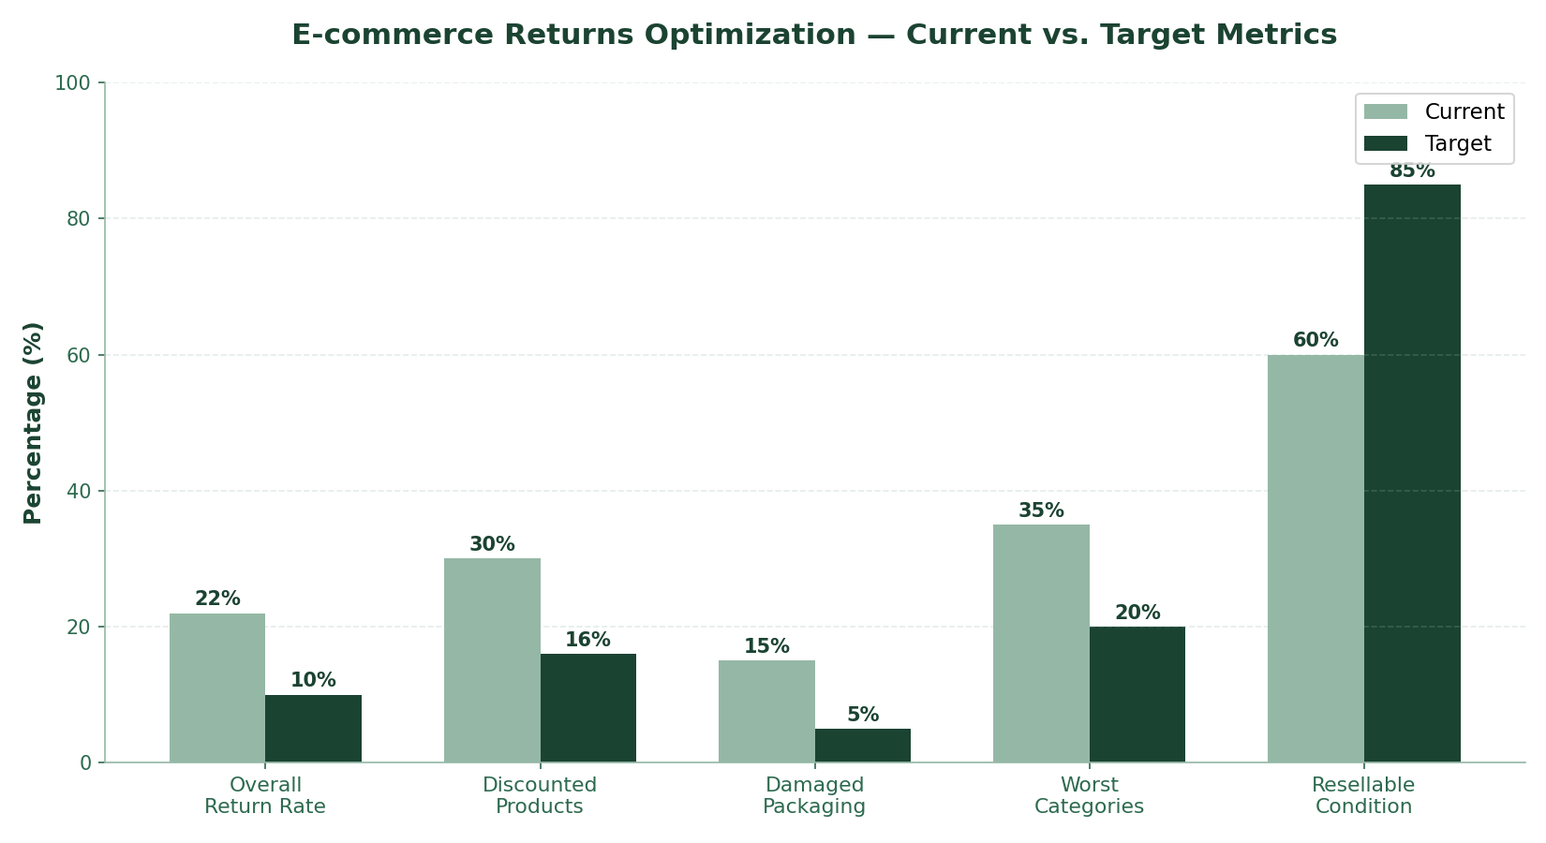

8. User Stories & Acceptance Criteria

Draft first version, to be reviewed and personalized.
- As a Marketing Manager, I want to see the return rate for discounted vs. non-discounted orders, so that I can determine whether our campaign strategy is contributing to returns.
- As an Operations Manager, I want to see return rates broken down by product category and supplier, so that I can identify which products need quality review.
- As a Warehouse Supervisor, I want to track the percentage of returns caused by damage, so that I can measure whether packaging improvements are working.
- As a Finance Analyst, I want a recurring view of the total cost of returns, so that I don't need to request a manual analysis every time I need this figure.
- As a Customer Service Agent, I want returns logged with a standardized reason code, so that recurring issues can be identified systematically rather than anecdotally.

Acceptance Criteria - Discount Return Rate Story
Given a set of orders within a selected date range,
When the Marketing Manager views the returns dashboard,
Then they see return rate percentages split by discounted and non-discounted orders, updated at least daily.

Acceptance Criteria - Return Reason Capture Story
Given a customer service agent is processing a return,
When they complete the return record,
Then they must select a return reason from a standardized list before the return can be finalized.

